**Project Title:** Trumps False Claims

**Project Team**: Clay, Don, Mac, Matt

**Project Overview**: We will scrape <https://www.washingtonpost.com/graphics/politics/trump-claims-database/> for false claims made by President Donald Trump using a Python flask app and utilize PostgreSQL to set up our database. We will use HTML, JavaScript / CSS as well the JavaScript AnyChart library to create 3 interactive visuals which will display the false claims by month, category and by topic using 3 types of charts. We chose this as it is a “hot-button” topic that we believe will become even more elevated as we near the November election.

**Project Link:** <https://github.com/cselleck/data-viz-group-project>

Interactive dropdown menus will allow the user to filter the bar chart by claim category.

**Lies by Topic**

**Lies by Category**

**Lies by Month**

Bar Chart Visual **– Lies by Month** – Filter by Category

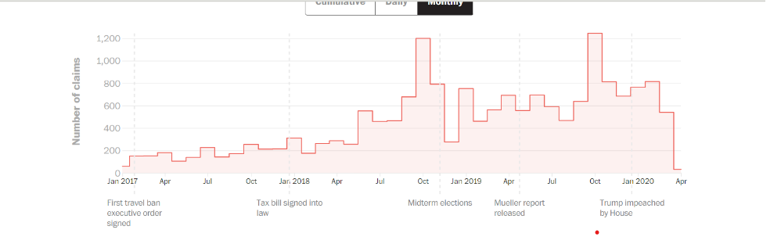

Pie Chart Visual – **Lies by Category** – may change to donut chart – Filter by Month

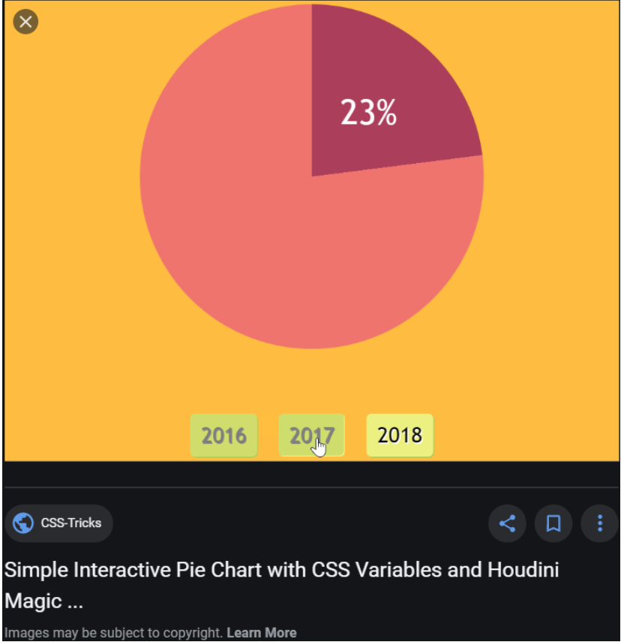

Word Cloud / AnyChart visual **– Lies by Topic** – Filter by Month

[**https://www.jasondavies.com/wordcloud/**](https://www.jasondavies.com/wordcloud/)

